

Assignment #01
Name: Zara Ahmed
Registration no: Fa25-BCS-060
Course name: Data Structure
Submission date:9 October,2026
Instructor: Bilal Bukhari

Tasks of Single linked list:
TASKS #01:
#include <iostream>
using namespace std;

struct Node
{
int data;
Node* next;
};

void displayReverse(Node* p)
{
if (p == NULL)
return;

displayReverse(p->next);
cout << p->data << " ";
}

int main()
{
Node* n1 = new Node;
Node* n2 = new Node;
Node* n3 = new Node;
Node* n4 = new Node;

n1->data = 1;
n2->data = 2;
n3->data = 3;
n4->data = 4;

n1->next = n2;
n2->next = n3;
n3->next = n4;
n4->next = NULL;

Node* head = n1;

cout << "Reverse order: ";
displayReverse(head);

return 0;
}
Output:
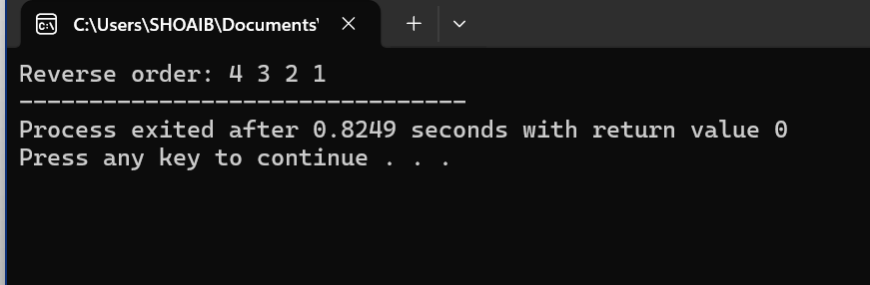
TASKS #02:
#include <iostream>
using namespace std;

struct Node
{
int data;
Node* next;
};

void display(Node* head)
{
while (head != NULL)
{
cout << head->data << " -> ";
head = head->next;
}

cout << "NULL";
}

void reverseList(Node*& head)
{
Node* prev = NULL;
Node* curr = head;

while (curr != NULL)
{
Node* next = curr->next;

curr->next = prev;

prev = curr;
curr = next;
}

head = prev;
}

int main()
{
Node* n1 = new Node;
Node* n2 = new Node;
Node* n3 = new Node;
Node* n4 = new Node;

n1->data = 1;
n2->data = 2;
n3->data = 3;
n4->data = 4;

n1->next = n2;
n2->next = n3;
n3->next = n4;
n4->next = NULL;

Node* head = n1;

cout << "Before: ";
display(head);

reverseList(head);

cout << "\nAfter: ";
display(head);

return 0;
}

Output:
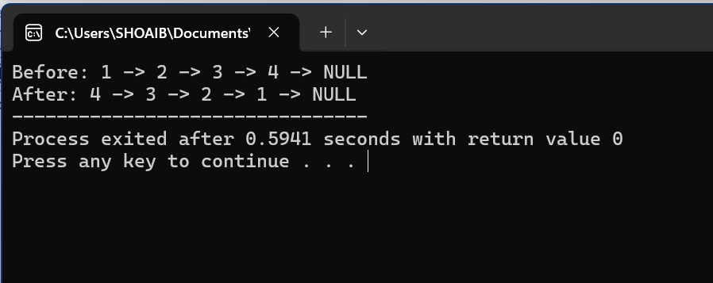

TASKS #03:
#include <iostream>
using namespace std;

struct Node
{
int data;
Node* next;
};

void display(Node* head)
{
while (head != NULL)
{
cout << head->data << " -> ";
head = head->next;
}

cout << "NULL";
}

void removeDuplicates(Node* head)
{
Node* p = head;

while (p != NULL)
{
Node* q = p;

while (q->next != NULL)
{
if (q->next->data == p->data)
{
Node* del = q->next;
q->next = q->next->next;
delete del;
}
else
{
q = q->next;
}
}

p = p->next;
}
}

int main()
{
Node* n1 = new Node;
Node* n2 = new Node;
Node* n3 = new Node;
Node* n4 = new Node;
Node* n5 = new Node;

n1->data = 10;
n2->data = 20;
n3->data = 10;
n4->data = 30;
n5->data = 20;

n1->next = n2;
n2->next = n3;
n3->next = n4;
n4->next = n5;
n5->next = NULL;

Node* head = n1;

cout << "Before: ";
display(head);

removeDuplicates(head);

cout << "\nAfter: ";
display(head);

return 0;
}
Output:
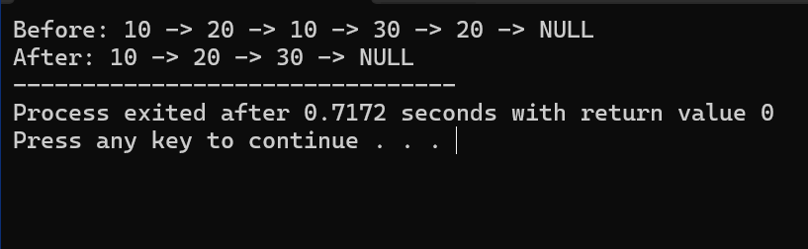

TASKS #04:
#include <iostream>
using namespace std;

struct Node
{
int data;
Node* next;
};

bool hasLoop(Node* head)
{
Node* slow = head;
Node* fast = head;

while (fast != NULL && fast->next != NULL)
{
slow = slow->next;
fast = fast->next->next;

if (slow == fast)
return true;
}

return false;
}

int main()
{
Node* n1 = new Node;
Node* n2 = new Node;
Node* n3 = new Node;
Node* n4 = new Node;

n1->data = 10;
n2->data = 20;
n3->data = 30;
n4->data = 40;

n1->next = n2;
n2->next = n3;
n3->next = n4;

// Creating a loop
n4->next = n2;

Node* head = n1;

if (hasLoop(head))
cout << "Loop exists";
else
cout << "No loop";

return 0;
}
Output:
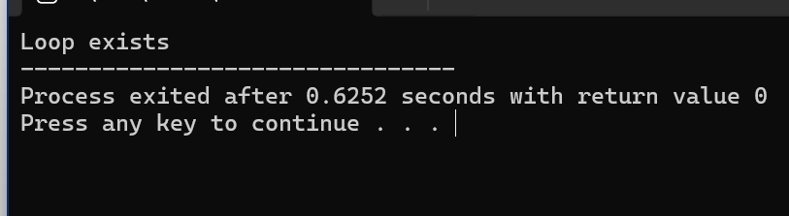

TASKS #05: #include <iostream>
using namespace std;

struct Node
{
int data;
Node* next;
};

Node* middleLeft(Node* head)
{
if (head == NULL)
return NULL;

Node* slow = head;
Node* fast = head;

while (fast->next != NULL && fast->next->next != NULL)
{
slow = slow->next;
fast = fast->next->next;
}

return slow;
}

int main()
{
Node* n1 = new Node;
Node* n2 = new Node;
Node* n3 = new Node;
Node* n4 = new Node;
Node* n5 = new Node;
Node* n6 = new Node;

n1->data = 1;
n2->data = 2;
n3->data = 3;
n4->data = 4;
n5->data = 5;
n6->data = 6;

n1->next = n2;
n2->next = n3;
n3->next = n4;
n4->next = n5;
n5->next = n6;
n6->next = NULL;

Node* head = n1;

Node* middle = middleLeft(head);

if (middle != NULL)
cout << "Middle node: " << middle->data;

return 0;
}
Output:
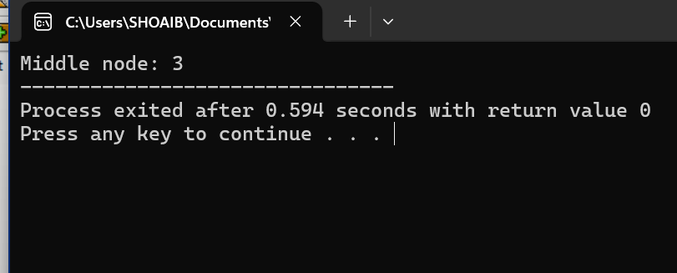

TASKS #06:
#include <iostream>
using namespace std;

struct Node
{
int data;
Node* next;
};

void display(Node* head)
{
while (head != NULL)
{
cout << head->data << " -> ";
head = head->next;
}

cout << "NULL";
}

void separateEvenOdd(Node* head, Node*& evenHead, Node*& oddHead)
{
Node* evenTail = NULL;
Node* oddTail = NULL;

evenHead = NULL;
oddHead = NULL;

Node* p = head;

while (p != NULL)
{
Node* next = p->next;
p->next = NULL;

if (p->data % 2 == 0)
{
if (evenHead == NULL)
{
evenHead = p;
evenTail = p;
}
else
{
evenTail->next = p;
evenTail = p;
}
}
else
{
if (oddHead == NULL)
{
oddHead = p;
oddTail = p;
}
else
{
oddTail->next = p;
oddTail = p;
}
}

p = next;
}
}

int main()
{
Node* n1 = new Node;
Node* n2 = new Node;
Node* n3 = new Node;
Node* n4 = new Node;
Node* n5 = new Node;
Node* n6 = new Node;

n1->data = 1;
n2->data = 2;
n3->data = 3;
n4->data = 4;
n5->data = 5;
n6->data = 6;

n1->next = n2;
n2->next = n3;
n3->next = n4;
n4->next = n5;
n5->next = n6;
n6->next = NULL;

Node* head = n1;
Node* evenHead;
Node* oddHead;

separateEvenOdd(head, evenHead, oddHead);

cout << "Even list: ";
display(evenHead);

cout << "\nOdd list: ";
display(oddHead);

return 0;
}

Output:
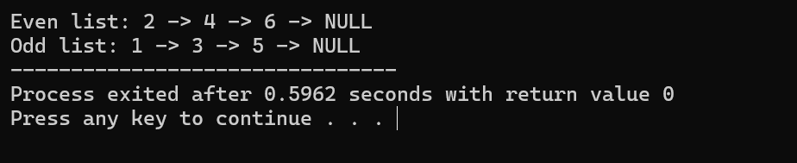

TASKS #07:
#include <iostream>
using namespace std;

struct Node
{
int data;
Node* next;
};

void display(Node* head)
{
while (head != NULL)
{
cout << head->data << " -> ";
head = head->next;
}

cout << "NULL";
}

void reverseHalves(Node*& head)
{
if (head == NULL || head->next == NULL)
return;

int count = 0;
Node* p = head;

while (p != NULL)
{
count++;
p = p->next;
}

int firstHalf = count / 2;

Node* secondStart = head;

for (int i = 0; i < firstHalf; i++)
{
secondStart = secondStart->next;
}

// Reverse first half
Node* prev = NULL;
Node* curr = head;

for (int i = 0; i < firstHalf; i++)
{
Node* next = curr->next;

curr->next = prev;
prev = curr;
curr = next;
}

Node* firstReversed = prev;
Node* firstTail = head;

// Reverse second half
prev = NULL;
curr = secondStart;

while (curr != NULL)
{
Node* next = curr->next;

curr->next = prev;
prev = curr;
curr = next;
}

firstTail->next = prev;
head = firstReversed;
}

int main()
{
Node* n1 = new Node;
Node* n2 = new Node;
Node* n3 = new Node;
Node* n4 = new Node;
Node* n5 = new Node;
Node* n6 = new Node;
Node* n7 = new Node;
Node* n8 = new Node;

n1->data = 1;
n2->data = 2;
n3->data = 3;
n4->data = 4;
n5->data = 5;
n6->data = 6;
n7->data = 7;
n8->data = 8;

n1->next = n2;
n2->next = n3;
n3->next = n4;
n4->next = n5;
n5->next = n6;
n6->next = n7;
n7->next = n8;
n8->next = NULL;

Node* head = n1;

cout << "Before: ";
display(head);

reverseHalves(head);

cout << "\nAfter: ";
display(head);

return 0;
}
Output:
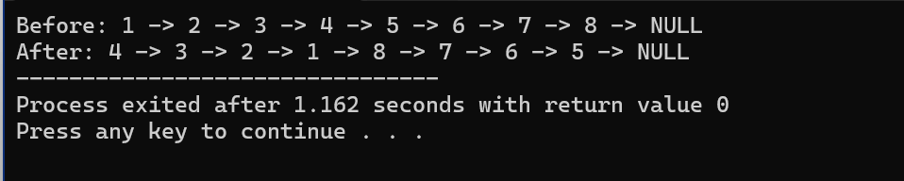

TASKS #08:
#include <iostream>
using namespace std;

struct Node
{
int data;
Node* next;
};

void display(Node* head)
{
while (head != NULL)
{
cout << head->data << " -> ";
head = head->next;
}

cout << "NULL";
}

void removeDuplicateStamps(Node* head)
{
Node* p = head;

while (p != NULL)
{
Node* q = p;

while (q->next != NULL)
{
if (q->next->data == p->data)
{
Node* del = q->next;
q->next = q->next->next;
delete del;
}
else
{
q = q->next;
}
}

p = p->next;
}
}

int main()
{
Node* n1 = new Node;
Node* n2 = new Node;
Node* n3 = new Node;
Node* n4 = new Node;
Node* n5 = new Node;
Node* n6 = new Node;

n1->data = 5;
n2->data = 8;
n3->data = 5;
n4->data = 2;
n5->data = 8;
n6->data = 9;

n1->next = n2;
n2->next = n3;
n3->next = n4;
n4->next = n5;
n5->next = n6;
n6->next = NULL;

Node* head = n1;

cout << "Before: ";
display(head);

removeDuplicateStamps(head);

cout << "\nAfter: ";
display(head);

return 0;
}

Output:

TASKS #09:
#include <iostream>
using namespace std;

struct Node
{
int data;
Node* next;
};

void display(Node* head)
{
while (head != NULL)
{
cout << head->data << " -> ";
head = head->next;
}

cout << "NULL";
}

void deleteAll(Node*& head, int key)
{
while (head != NULL && head->data == key)
{
Node* del = head;
head = head->next;
delete del;
}

if (head == NULL)
return;

Node* p = head;

while (p->next != NULL)
{
if (p->next->data == key)
{
Node* del = p->next;
p->next = p->next->next;
delete del;
}
else
{
p = p->next;
}
}
}

int main()
{
Node* n1 = new Node;
Node* n2 = new Node;
Node* n3 = new Node;
Node* n4 = new Node;
Node* n5 = new Node;
Node* n6 = new Node;

n1->data = 5;
n2->data = 2;
n3->data = 5;
n4->data = 8;
n5->data = 5;
n6->data = 9;

n1->next = n2;
n2->next = n3;
n3->next = n4;
n4->next = n5;
n5->next = n6;
n6->next = NULL;

Node* head = n1;

cout << "Before: ";
display(head);

int key = 5;

deleteAll(head, key);

cout << "\nAfter deleting " << key << ": ";
display(head);

return 0;
}
Output:
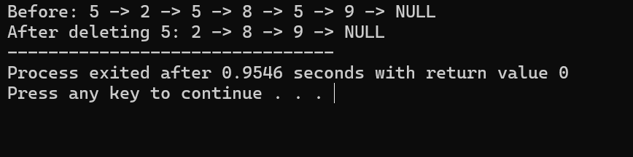

TASKS #10:
#include <iostream>
using namespace std;

struct Node
{
int data;
Node* next;
};

void display(Node* head)
{
while (head != NULL)
{
cout << head->data << " -> ";
head = head->next;
}

cout << "NULL";
}

void pairSwap(Node*& head)
{
Node* prev = NULL;
Node* curr = head;

while (curr != NULL && curr->next != NULL)
{
Node* second = curr->next;

curr->next = second->next;
second->next = curr;

if (prev == NULL)
{
head = second;
}
else
{
prev->next = second;
}

prev = curr;
curr = curr->next;
}
}

int main()
{
Node* n1 = new Node;
Node* n2 = new Node;
Node* n3 = new Node;
Node* n4 = new Node;
Node* n5 = new Node;
Node* n6 = new Node;

n1->data = 1;
n2->data = 2;
n3->data = 3;
n4->data = 4;
n5->data = 5;
n6->data = 6;

n1->next = n2;
n2->next = n3;
n3->next = n4;
n4->next = n5;
n5->next = n6;
n6->next = NULL;

Node* head = n1;

cout << "Input: ";
display(head);

pairSwap(head);

cout << "\nOutput: ";
display(head);

return 0;
}

Output:

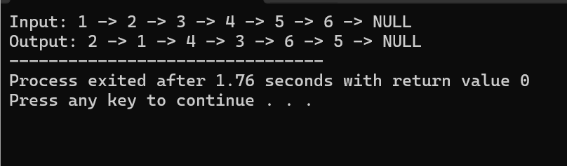

Tasks of Double Linked list
TASKS #01:
#include <iostream>
using namespace std;

struct Node
{
int data;
Node* next;
Node* prev;
};

void display(Node* head)
{
Node* p = head;

while (p != NULL)
{
cout << p->data << " <-> ";
p = p->next;
}

cout << "NULL";
}

void swapEnds(Node* head, Node* tail)
{
Node* left = head;
Node* right = tail;

while (left != right && left->prev != right)
{
int temp = left->data;
left->data = right->data;
right->data = temp;

left = left->next;
right = right->prev;
}
}

int main()
{
Node* n1 = new Node;
Node* n2 = new Node;
Node* n3 = new Node;
Node* n4 = new Node;
Node* n5 = new Node;
Node* n6 = new Node;

n1->data = 1;
n2->data = 2;
n3->data = 3;
n4->data = 4;
n5->data = 5;
n6->data = 6;

n1->prev = NULL;
n1->next = n2;

n2->prev = n1;
n2->next = n3;

n3->prev = n2;
n3->next = n4;

n4->prev = n3;
n4->next = n5;

n5->prev = n4;
n5->next = n6;

n6->prev = n5;
n6->next = NULL;

Node* head = n1;
Node* tail = n6;

cout << "Before: ";
display(head);

swapEnds(head, tail);

cout << "\nAfter: ";
display(head);

return 0;
}

Output:
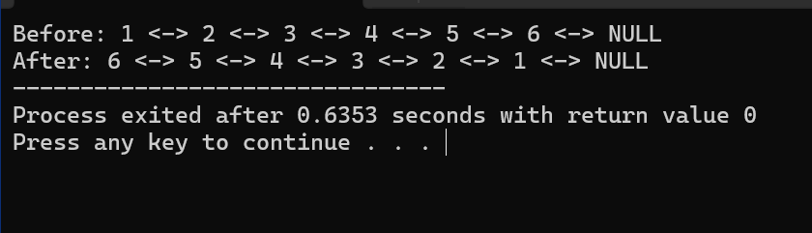

TASKS #02:
#include <iostream>
using namespace std;

struct Node
{
int data;
Node* next;
Node* prev;
};

void displayForward(Node* head)
{
Node* p = head;

while (p != NULL)
{
cout << p->data << " <-> ";
p = p->next;
}

cout << "NULL";
}

void displayBackward(Node* tail)
{
Node* p = tail;

while (p != NULL)
{
cout << p->data << " <-> ";
p = p->prev;
}

cout << "NULL";
}

int main()
{
Node* n1 = new Node;
Node* n2 = new Node;
Node* n3 = new Node;
Node* n4 = new Node;

n1->data = 1;
n2->data = 2;
n3->data = 3;
n4->data = 4;

n1->prev = NULL;
n1->next = n2;

n2->prev = n1;
n2->next = n3;

n3->prev = n2;
n3->next = n4;

n4->prev = n3;
n4->next = NULL;

Node* head = n1;
Node* tail = n4;

cout << "Forward: ";
displayForward(head);

cout << "\nBackward: ";
displayBackward(tail);

return 0;
}
Output:
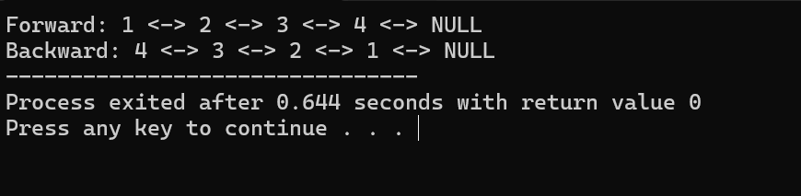

TASKS #03:
#include <iostream>
using namespace std;

struct Item
{
int data;
Item* next;
Item* prev;
};

struct Section
{
char name[20];
Section* next;
Section* prev;

Item* itemHead;
Item* itemTail;
};

struct Store
{
char name[20];
Store* next;
Store* prev;

Section* sectionHead;
Section* sectionTail;
};

void copyName(char a[], const char b[])
{
int i = 0;

while (b[i] != '\0')
{
a[i] = b[i];
i++;
}

a[i] = '\0';
}

Store* findStore(Store* head, const char name[])
{
Store* p = head;

while (p != NULL)
{
int i = 0;
bool same = true;

while (name[i] != '\0' || p->name[i] != '\0')
{
if (name[i] != p->name[i])
{
same = false;
break;
}

i++;
}

if (same)
return p;

p = p->next;
}

return NULL;
}

Section* findSection(Store* store, const char name[])
{
Section* p = store->sectionHead;

while (p != NULL)
{
int i = 0;
bool same = true;

while (name[i] != '\0' || p->name[i] != '\0')
{
if (name[i] != p->name[i])
{
same = false;
break;
}

i++;
}

if (same)
return p;

p = p->next;
}

return NULL;
}

void addSection(Store* store, const char name[])
{
Section* p = new Section;

copyName(p->name, name);

p->next = NULL;
p->prev = store->sectionTail;

p->itemHead = NULL;
p->itemTail = NULL;

if (store->sectionHead == NULL)
{
store->sectionHead = p;
store->sectionTail = p;
}
else
{
store->sectionTail->next = p;
store->sectionTail = p;
}
}

void addItem(Store* store, const char sectionName[], int value)
{
Section* section = findSection(store, sectionName);

if (section == NULL)
return;

Item* p = new Item;

p->data = value;
p->next = NULL;
p->prev = section->itemTail;

if (section->itemHead == NULL)
{
section->itemHead = p;
section->itemTail = p;
}
else
{
section->itemTail->next = p;
section->itemTail = p;
}
}

void removeItem(Store* store, const char sectionName[], int value)
{
Section* section = findSection(store, sectionName);

if (section == NULL)
return;

Item* p = section->itemHead;

while (p != NULL)
{
if (p->data == value)
{
if (p->prev != NULL)
p->prev->next = p->next;
else
section->itemHead = p->next;

if (p->next != NULL)
p->next->prev = p->prev;
else
section->itemTail = p->prev;

delete p;
return;
}

p = p->next;
}
}

void displaySection(Store* store, const char sectionName[])
{
Section* section = findSection(store, sectionName);

if (section == NULL)
return;

cout << section->name << ": ";

Item* p = section->itemHead;

while (p != NULL)
{
cout << p->data << " ";
p = p->next;
}

cout << endl;
}

void displayStore(Store* store)
{
cout << "Store: " << store->name << endl;

Section* section = store->sectionHead;

while (section != NULL)
{
cout << section->name << ": ";

Item* p = section->itemHead;

while (p != NULL)
{
cout << p->data << " ";
p = p->next;
}

cout << endl;

section = section->next;
}
}

int main()
{
Store* store = new Store;

copyName(store->name, "Store1");

store->prev = NULL;
store->next = NULL;

store->sectionHead = NULL;
store->sectionTail = NULL;

addSection(store, "Grocery");
addSection(store, "Fruits");

addItem(store, "Grocery", 100);
addItem(store, "Grocery", 200);

addItem(store, "Fruits", 50);
addItem(store, "Fruits", 80);

cout << "Before removal:\n";
displayStore(store);

removeItem(store, "Grocery", 100);

cout << "\nAfter removal:\n";
displayStore(store);

return 0;
}
Output:
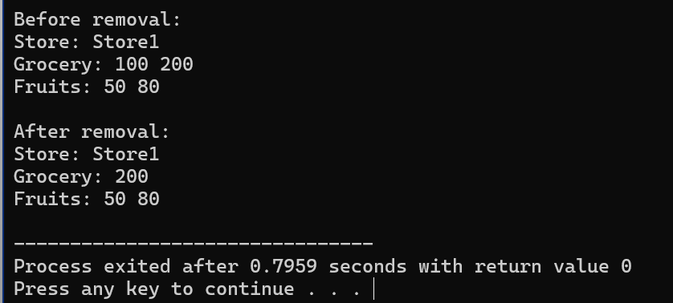

TASKS #04:
#include <iostream>
using namespace std;

struct Node
{
int data;
Node* next;
Node* prev;
};

void display(Node* head)
{
Node* p = head;

while (p != NULL)
{
cout << p->data << " -> ";
p = p->next;
}

cout << "NULL";
}

void specialSwap(Node* head, Node* tail)
{
Node* left = head->next;
Node* right = tail->prev;

while (left != right && left->prev != right)
{
int temp = left->data;
left->data = right->data;
right->data = temp;

left = left->next->next;
right = right->prev->prev;
}
}

int main()
{
Node* n1 = new Node;
Node* n2 = new Node;
Node* n3 = new Node;
Node* n4 = new Node;
Node* n5 = new Node;
Node* n6 = new Node;
Node* n7 = new Node;
Node* n8 = new Node;
Node* n9 = new Node;

n1->data = 1;
n2->data = 2;
n3->data = 3;
n4->data = 4;
n5->data = 5;
n6->data = 6;
n7->data = 7;
n8->data = 8;
n9->data = 9;

n1->prev = NULL;
n1->next = n2;

n2->prev = n1;
n2->next = n3;

n3->prev = n2;
n3->next = n4;

n4->prev = n3;
n4->next = n5;

n5->prev = n4;
n5->next = n6;

n6->prev = n5;
n6->next = n7;

n7->prev = n6;
n7->next = n8;

n8->prev = n7;
n8->next = n9;

n9->prev = n8;
n9->next = NULL;

Node* head = n1;
Node* tail = n9;

cout << "Before: ";
display(head);

specialSwap(head, tail);

cout << "\nAfter: ";
display(head);

return 0;
}
Output:
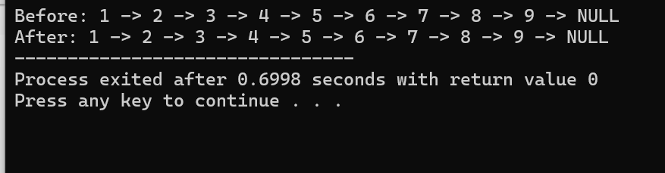

Tasks of Circular Linked List
TASKS #01:
#include <iostream>
using namespace std;

struct Node
{
int data;
Node* next;
};

void createCircle(Node*& head, Node*& tail, int n)
{
head = NULL;
tail = NULL;

for (int i = 1; i <= n; i++)
{
Node* p = new Node;

p->data = i;
p->next = NULL;

if (head == NULL)
{
head = p;
tail = p;
}
else
{
tail->next = p;
tail = p;
}
}

if (tail != NULL)
tail->next = head;
}

int josephus(Node*& head, Node*& tail, int n, int m)
{
Node* current = head;
Node* previous = tail;

while (n > 1)
{
for (int i = 1; i < m; i++)
{
previous = current;
current = current->next;
}

cout << "Killed: " << current->data << endl;

previous->next = current->next;

if (current == head)
head = current->next;

delete current;

current = previous->next;

n--;
}

tail = previous;
tail->next = head;

return head->data;
}

int main()
{
int n;
int m;

cout << "Enter number of persons: ";
cin >> n;

cout << "Enter M: ";
cin >> m;

if (n <= 0 || m <= 0)
{
cout << "Invalid input";
return 0;
}

Node* head = NULL;
Node* tail = NULL;

createCircle(head, tail, n);

int survivor = josephus(head, tail, n, m);

cout << "Survivor: " << survivor;

return 0;
}
Output:
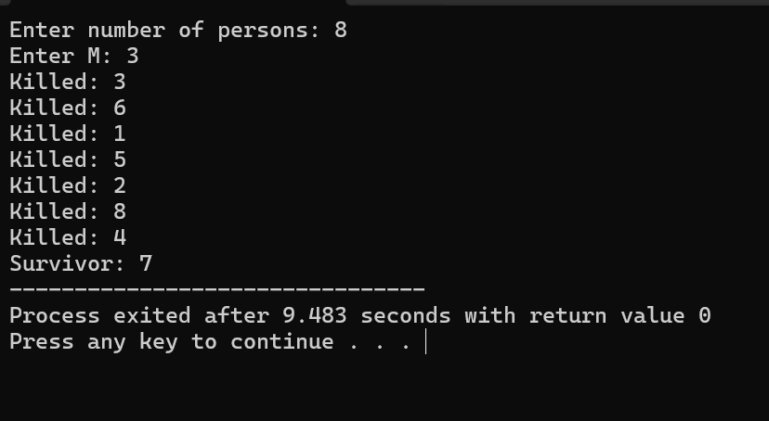

TASKS #02:
#include <iostream>
using namespace std;

struct Node
{
char name[30];
int priority;
char status[20];

Node* next;
};

Node* head = NULL;
Node* tail = NULL;
Node* current = NULL;

void copyText(char a[], const char b[])
{
int i = 0;

while (b[i] != '\0')
{
a[i] = b[i];
i++;
}

a[i] = '\0';
}

bool sameText(const char a[], const char b[])
{
int i = 0;

while (a[i] != '\0' || b[i] != '\0')
{
if (a[i] != b[i])
return false;

i++;
}

return true;
}

// Add task at end
void addTask(const char name[], int priority, const char status[])
{
Node* p = new Node;

copyText(p->name, name);

p->priority = priority;

copyText(p->status, status);

if (head == NULL)
{
head = p;
tail = p;

p->next = head;
current = head;
}
else
{
p->next = head;

tail->next = p;
tail = p;
}
}

// Remove task by name
void removeTask(const char name[])
{
if (head == NULL)
{
cout << "List is empty" << endl;
return;
}

Node* previous = tail;
Node* p = head;

do
{
if (sameText(p->name, name))
{
if (p == head && p == tail)
{
head = NULL;
tail = NULL;
current = NULL;
}
else
{
previous->next = p->next;

if (p == head)
head = p->next;

if (p == tail)
tail = previous;

tail->next = head;

if (current == p)
current = p->next;
}

delete p;

cout << "Task removed" << endl;
return;
}

previous = p;
p = p->next;

} while (p != head);

cout << "Task not found" << endl;
}

// Get next pending task
void getNextTask()
{
if (head == NULL)
{
cout << "List is empty" << endl;
return;
}

Node* start = current;
Node* p = current;

do
{
if (sameText(p->status, "pending"))
{
current = p;

cout << "Next Task" << endl;
cout << "Name: " << p->name << endl;
cout << "Priority: " << p->priority << endl;
cout << "Status: " << p->status << endl;

return;
}

p = p->next;

} while (p != start);

cout << "No pending task found" << endl;
}

// Display all tasks
void displayAll()
{
if (head == NULL)
{
cout << "List is empty" << endl;
return;
}

Node* p = head;

cout << "\nAll Tasks" << endl;

do
{
cout << "Name: " << p->name << endl;
cout << "Priority: " << p->priority << endl;
cout << "Status: " << p->status << endl;
cout << endl;

p = p->next;

} while (p != head);
}

// Update status
void updateStatus(const char name[], const char newStatus[])
{
if (head == NULL)
{
cout << "List is empty" << endl;
return;
}

Node* p = head;

do
{
if (sameText(p->name, name))
{
copyText(p->status, newStatus);

cout << "Updated Task" << endl;
cout << "Name: " << p->name << endl;
cout << "Priority: " << p->priority << endl;
cout << "Status: " << p->status << endl;

return;
}

p = p->next;

} while (p != head);

cout << "Task not found" << endl;
}

int main()
{
// Add tasks
addTask("TaskA", 1, "pending");
addTask("TaskB", 2, "completed");
addTask("TaskC", 3, "pending");
addTask("TaskD", 4, "completed");

displayAll();

cout << "\nGet Next Task:" << endl;
getNextTask();

cout << "\nUpdating TaskB:" << endl;
updateStatus("TaskB", "pending");

cout << "\nGet Next Task Again:" << endl;
getNextTask();

cout << "\nRemoving TaskD:" << endl;
removeTask("TaskD");

cout << "\nFinal List:" << endl;
displayAll();

return 0;
}
Output:

